**JUnit_Basic Testing Exercises**

**Exercise 1: Setting Up JUnit**

Scenario:

You need to set up JUnit in your Java project to start writing unit tests.

Steps:

1. Create a new Java project in your IDE (e.g., IntelliJ IDEA, Eclipse).

2. Add JUnit dependency to your project. If you are using Maven, add the following to your

pom.xml:

<dependency>

<groupId>junit</groupId>

<artifactId>junit</artifactId>

<version>4.13.2</version>

<scope>test</scope>

</dependency>

3. Create a new test class in your project.

**IMPLEMENTATION IN ECLIPSE :**

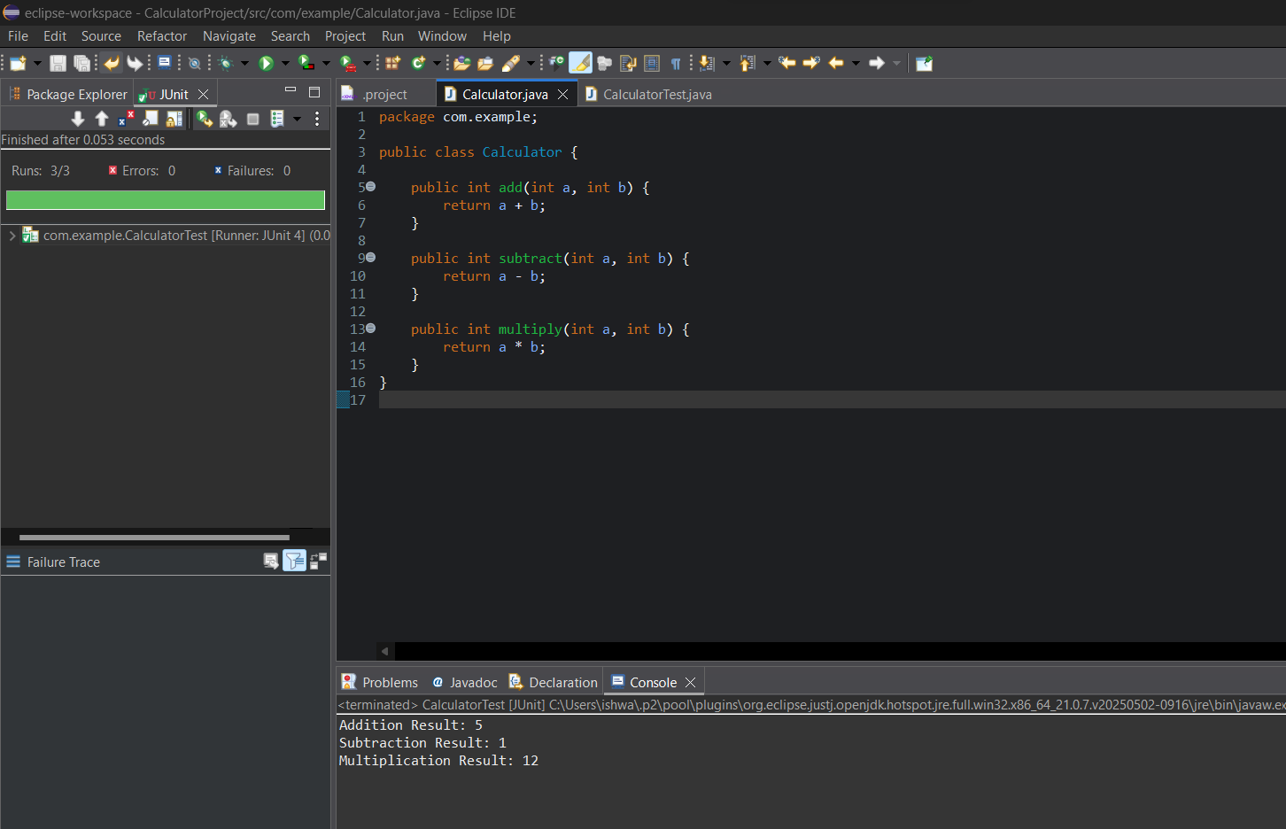

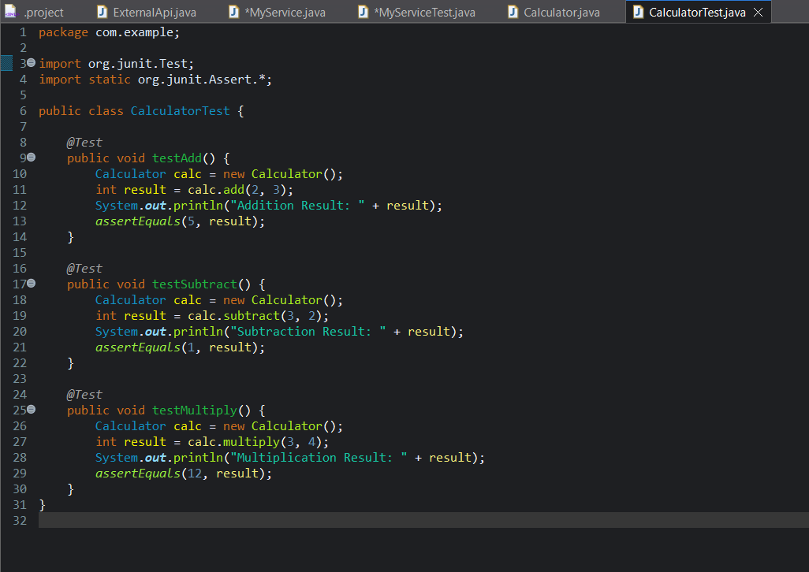

**OUTPUT :**

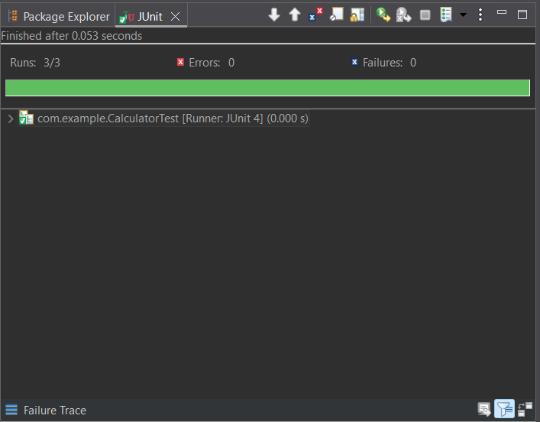

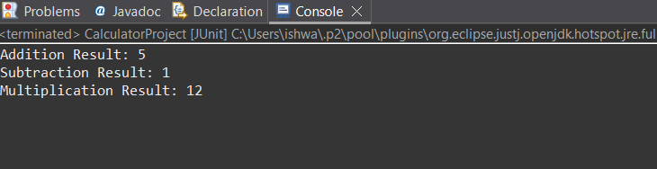

**PROGRAM :**

package com.example;

public class Calculator {

public int add(int a, int b) {

return a + b;

}

public int subtract(int a, int b) {

return a - b;

}

public int multiply(int a, int b) {

return a * b;

}

}

package com.example;

import org.junit.Test;

import static org.junit.Assert.*;

public class CalculatorTest {

*@Test*

public void testAdd() {

Calculator calc = new Calculator();

int result = calc.add(2, 3);

System.***out***.println("Addition Result: " + result);

*assertEquals*(5, result);

}

*@Test*

public void testSubtract() {

Calculator calc = new Calculator();

int result = calc.subtract(3, 2);

System.***out***.println("Subtraction Result: " + result);

*assertEquals*(1, result);

}

*@Test*

public void testMultiply() {

Calculator calc = new Calculator();

int result = calc.multiply(3, 4);

System.***out***.println("Multiplication Result: " + result);

*assertEquals*(12, result);

}

}

**OUTPUT :**



